 | Patient Assessment Record – SOAP Note |  |  |  | Venture Crew 80
Notified |  | On Scene | Scene Safe? | Incident Occurred |  | Notify 9-1-1? Y N
Date & Time |  | Time |  | Time |  | Time
Airway Breathing Circulation (Chunk) Disability Environment
S | Age |  |  |  |  | Sex M F |  | Name |  |  |  |  |  |  |  |  |  |  | Unit
Health Form - Permission to treat? Y N |  |  |  |  |  |  |  |  | Address, or contact |  |  |  |  |  |  |  |  | Phone
MOI |  |  | Mechanism Of Injury |  |  |  |  |  |  |  | City, State ZIP
C/C Patient's Chief Complaint
HPI |  |  | H_{x} of Present Illness: Location, Onset, Duration, Frequency, Quality, Quantity, Exacerbations, Reliefs, Prior H_{x} of same
Vitals (OMIT sections you are not trained/certified to complete) |  |  |  |  |  |  |  |  |  |  |  |  |  |  |  |  | Front |  |  | Rear
O | Time↓ |  |  |  |  |  |  |  |  |  |  |  |  |  |  | 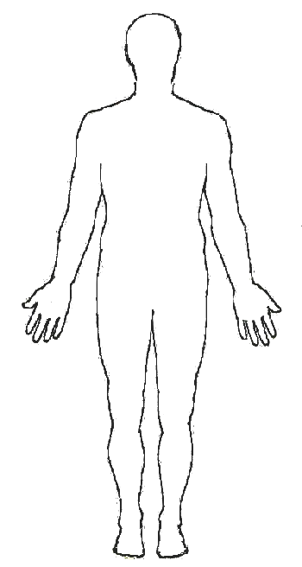
LOC A+O^{x} VPU
Skin c t m
H R r q
R R r q
Pupils perrla
BP
Patient exam locations of pain, tenderness, injuries, Circulation Sensation Motion
Signs / Symptoms
Allergies
Meds R_{x}, OTC, Rec.
Past Pertinent Med H_{x}
Last Oral Intake, Outputs
Events leading to accident/illness
A |  | Assessment (problems)
1 Possible |  |  |  |  |  |  |  |  |  |  |  |  |  |  |  |  |  |  |  |  | R Y G
2 Possible |  |  |  |  |  |  |  |  |  |  |  |  |  |  |  |  |  |  |  |  | R Y G
3 Possible |  |  |  |  |  |  |  |  |  |  |  |  |  |  |  |  |  |  |  |  | R Y G
4 Possible |  |  |  |  |  |  |  |  |  |  |  |  |  |  |  |  |  |  |  |  | R Y G
P |  | Plan for each problem and for getting help
1
2
3
4
 | Monitor Interval
EVAC? Y N |  |  | Date & Time |  | By:
Care by: |  |  |  |  | Care by:
Care by: |  |  |  |  | Care by:
If patient is transported, send a copy with the patient W3bsa.org 7/28/26

